**WORLD'S MOST YOUTUBE CHANNEL**

**Submitted by**

**Team id**

**NM2023TMID20001**

**Team members id**

**1.NANDHINI G (Team Leader)**

**76C2D766081359EA4724554940D57B68**

**2.KAVIYA C**

**D9C6EDF19D92AB19FB941502DFD388BC**

**3.MAHALAKSHMI K**

**BF1F148A67A620D8F2C4D43BAB7D72A2**

**4.MAREESHWARI L**

**B0407A4A66601FFBE9B4EC6ECD778E13**

Under the guidance of

**Dr. K. Lilly Mary Eucharista**

**Assistant Professor**

**Department of Physics**

**Sri Meenakshi Government Arts College for Women (A)**



October 2023

1.INTRODUCTION:

1.1 OVERVIEW:

Indian record label T-Series is the most subscribed channel, with over 250 million subscribers as of october 2023.

American youtube personality Mr. Beast is the most subscribed individual and second most subscribed channel overall,with 194 million subscribers as of october 2023.

1.2 PURPOSE:

Use:

Watch and like videos and subscribe to channels with Google Account. But without a youtube channel, we have no public presence on youtube.

Even if we have a Google Account, we need to create a youtube channel to upload Videos, Comment, or make playlists.

Achivements by using this:

Silver Button: when reach 1,00,000 subscribrs.

Gold Button: when reach 10,00,000 subscribers.

Diamond Button: when reach 1,00,00,000 subscribers.

Red Diamond: when reach 10,00,00,000 subscribers.

2.PROBLEM DEFINITION &DESIGN THINKING:

2.1 EMPATHY MAP:

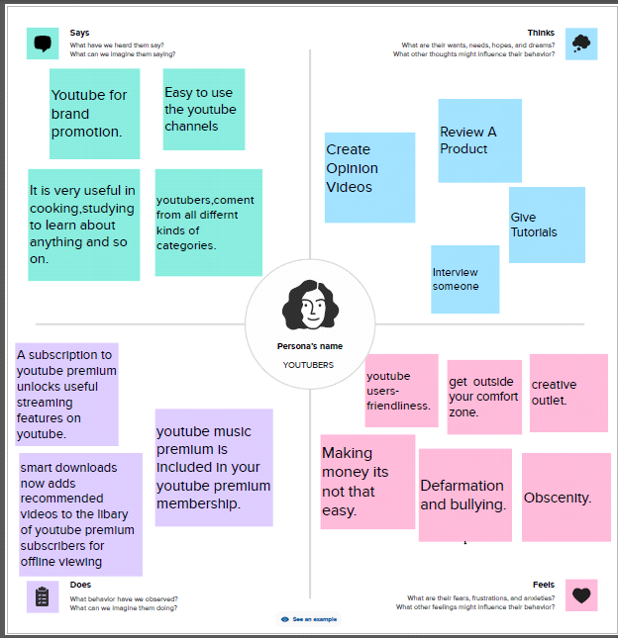

2.2 IDEATION & BRAINSTORMING MAP:

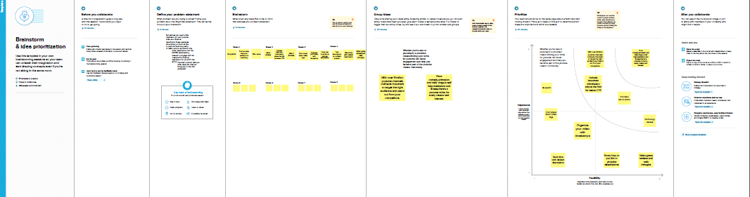

3.RESULT:

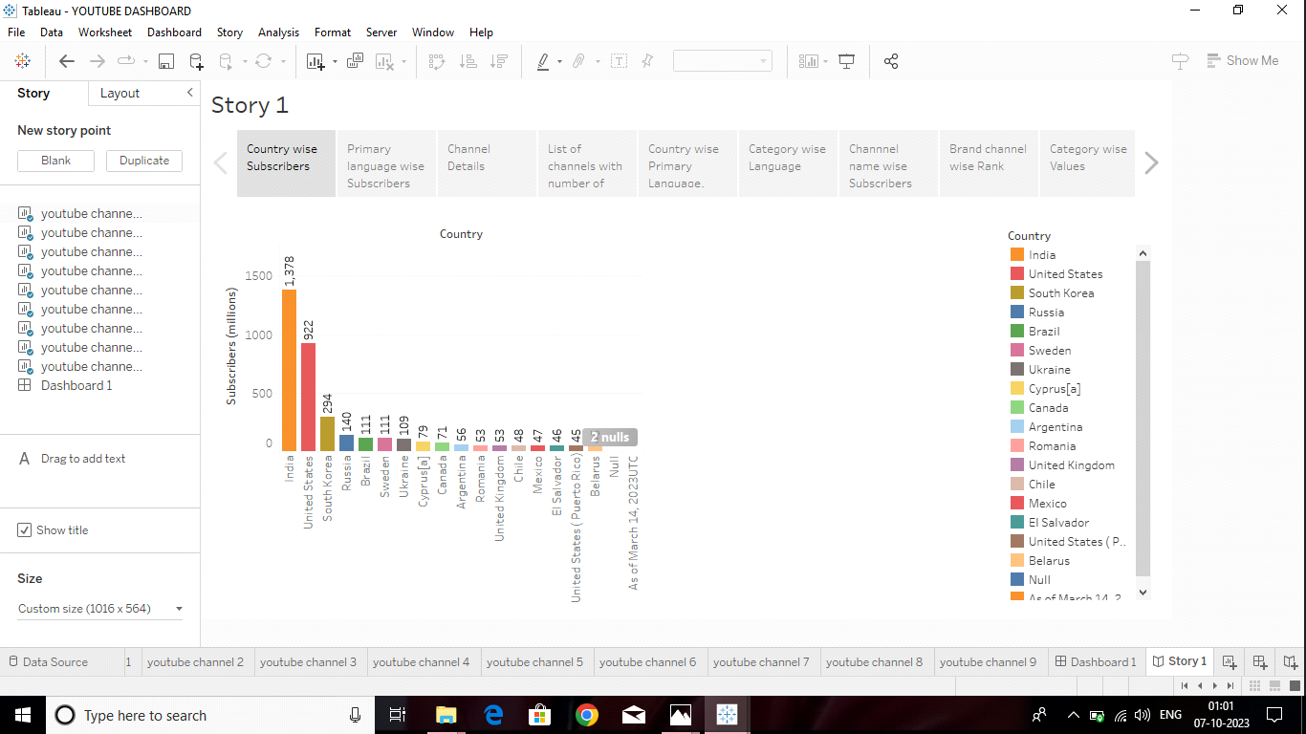

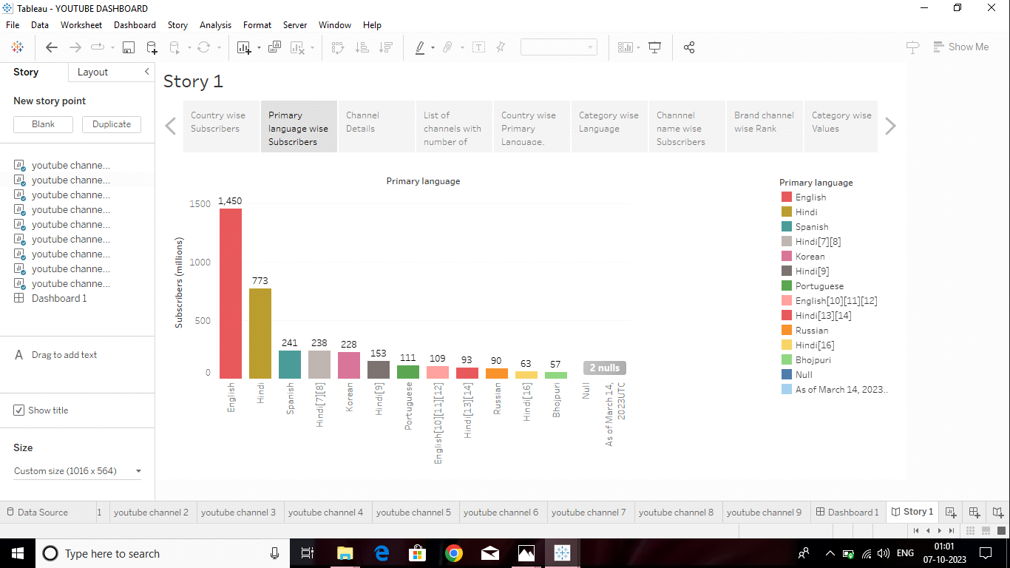

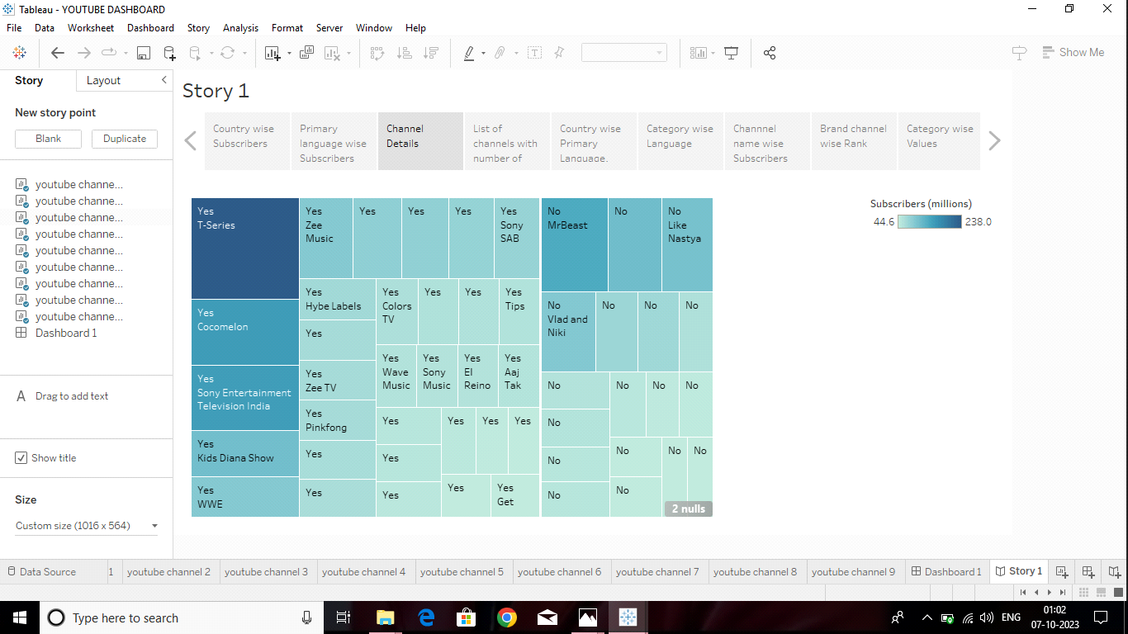

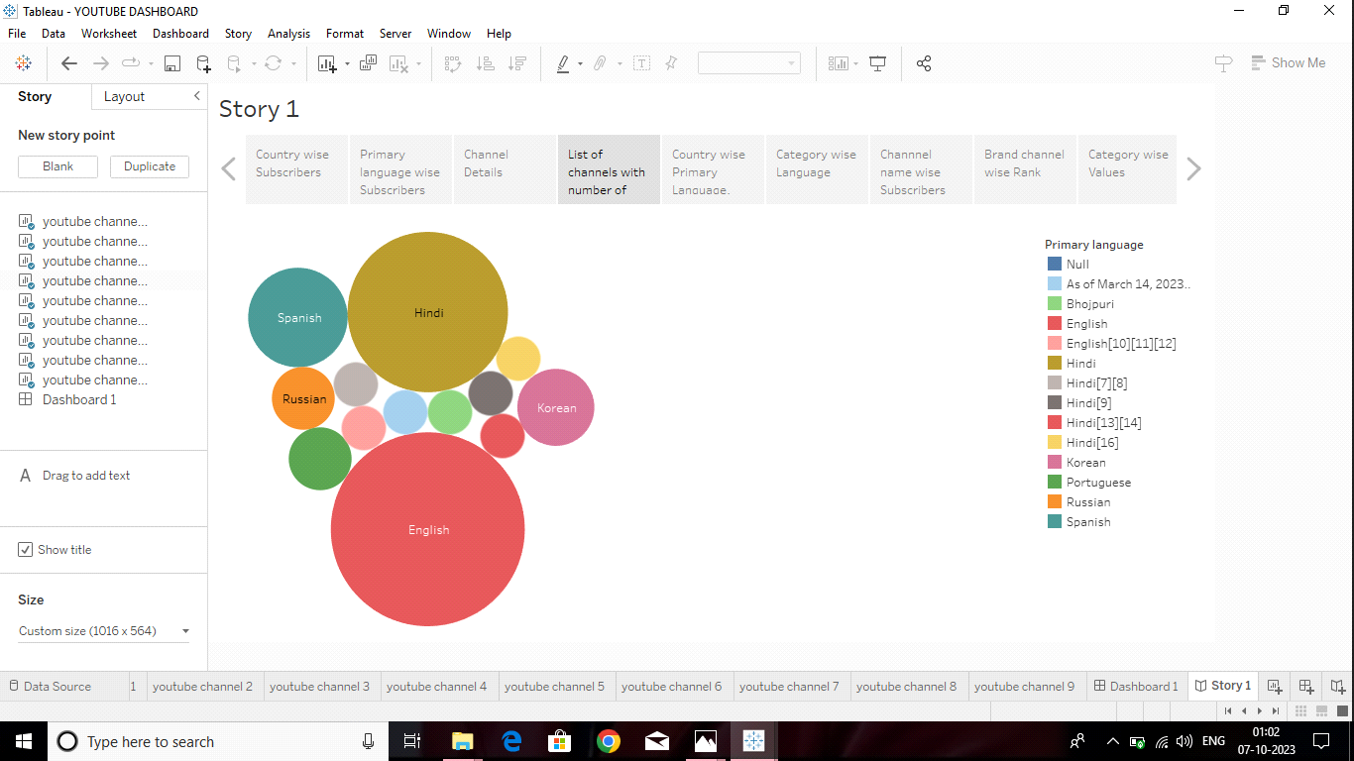

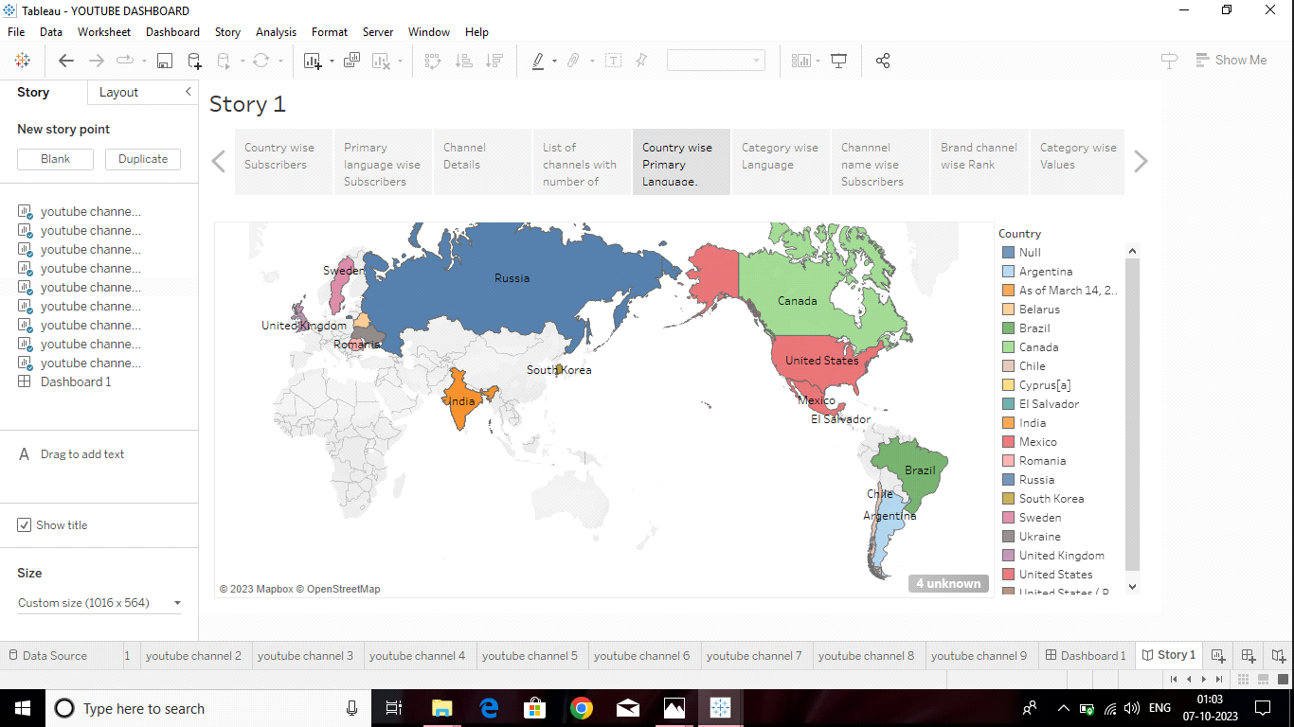

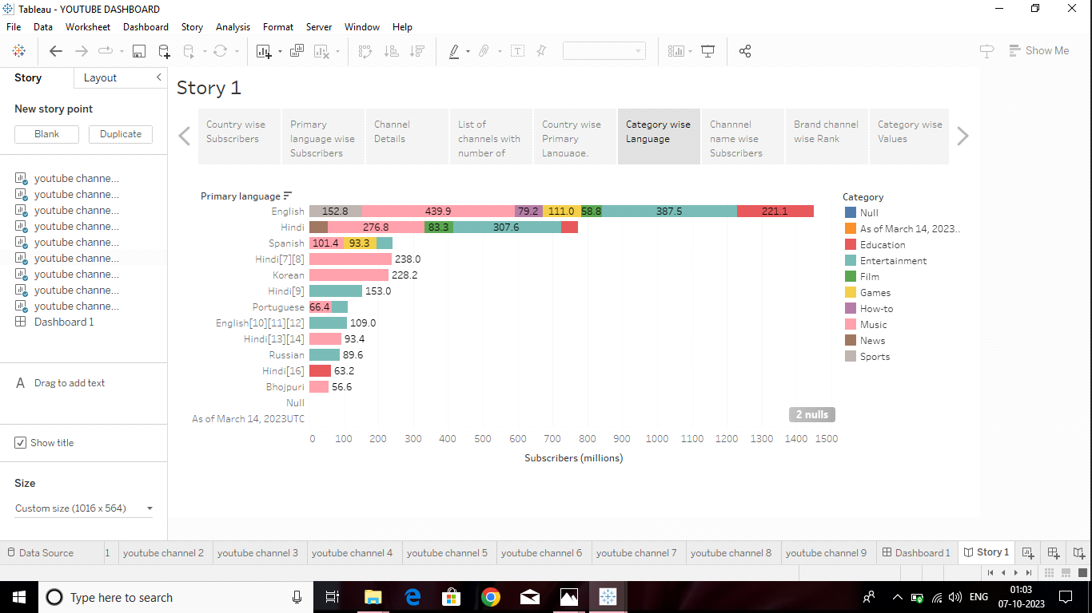

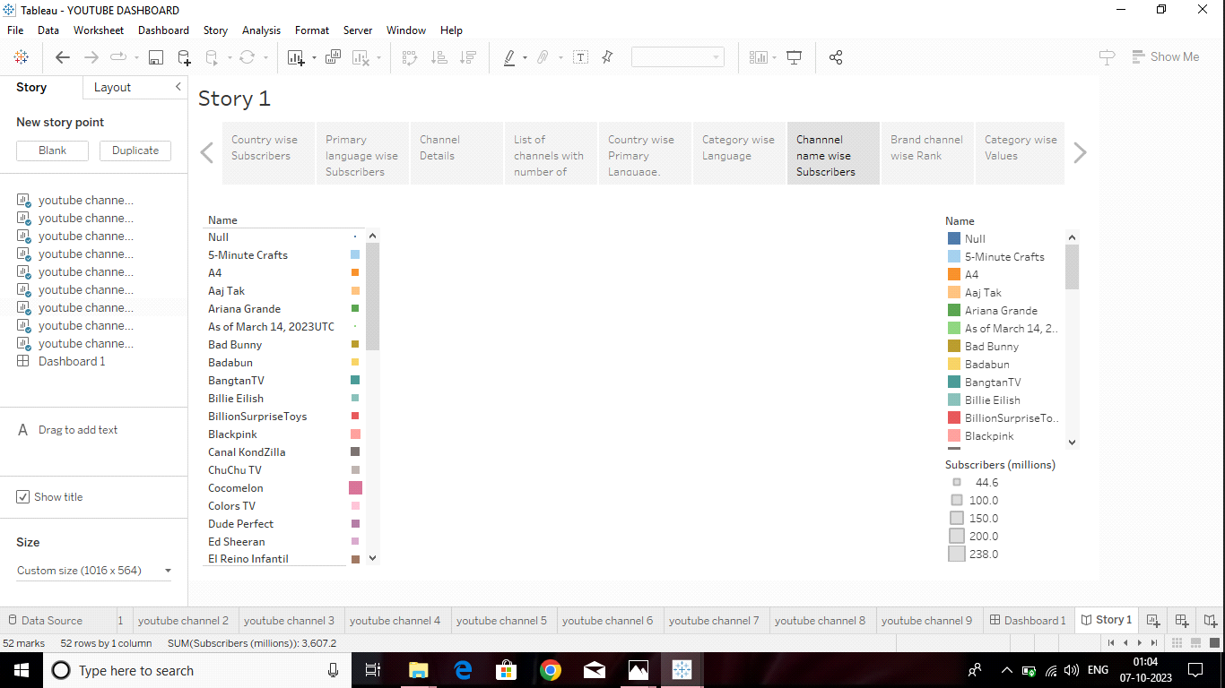

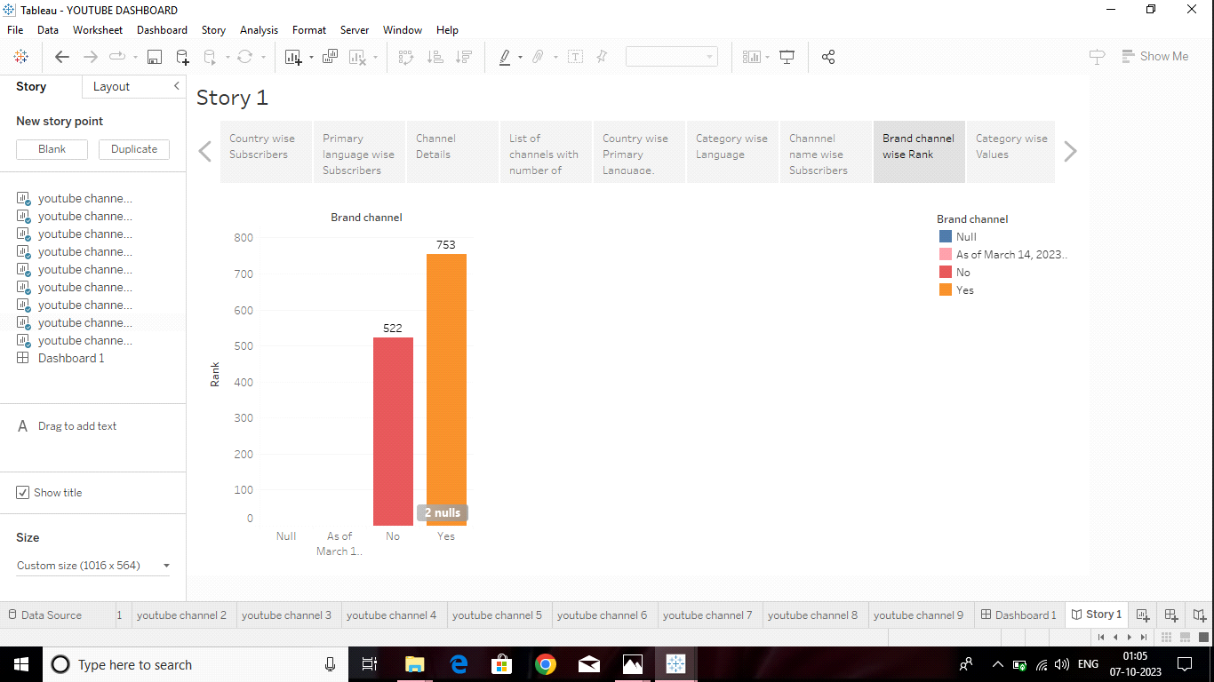

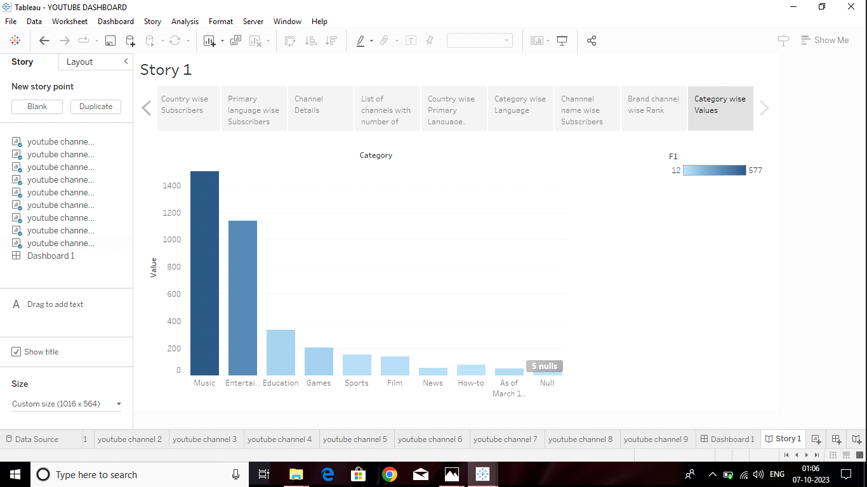

4.ADVANTAGES & DISADVANTAGES:

Advantages:

Youtube's user- Friendliness.

Youtube for Brand promotion.

Creative Outlet.

Modernizing.

Youtube benefits Talented People.

Disadvantages:

Making Money is not that Easy.

Defarmation and Bullying.

Obscenity.

Ads.

5.APPLICATION:

For entrepreneurs and content creators, youtube can also be used to build and audience, attract leads, and convert them into paying student for their online courses.

In some cases, buliding and educational channel can even be the fountadion for an edtech business.

6. CONCULISON:

In conclusion, youtube is a very strong growing platform creating lots of opportunites for entrepreneurs and motivated people.

youtube has an important part in education, because it allows students to earn more about a particular topic or subject just by watching a short video.

7.FUTURE SCOPE:

It is a field that offers tremendous scope for growth and other benefits such as flexibility of work, the ability to express yourself, opportunities to showcase your creativity, and a shot at earning popularity and Fame.